**What is Database?**

A database is an organized collection of data, stored and retrieved digitally from a remote or local computer system. Databases can be vast and complex, and such databases are developed using fixed design and modeling approaches.

**What is DBMS?**

DBMS stands for Database Management System. DBMS is a system software responsible for the creation, retrieval, updation and management of the database. It ensures that our data is consistent, organized and is easily accessible by serving as an interface between the database and its end users or application softwares.

**What is RDBMS? How is it different from DBMS?**

RDBMS stands for Relational Database Management System. The key difference here, compared to DBMS, is that RDBMS stores data in the form of a collection of tables and relations can be defined between the common fields of these tables. Most modern database management systems like MySQL, Microsoft SQL Server, Oracle, IBM DB2 and Amazon Redshift are based on RDBMS.

**What is SQL?**

SQL stands for Structured Query Language. It is the standard language for relational database management systems. It is especially useful in handling organized data comprised of entities (variables) and relations between different entities of the data.

**What is the difference between SQL and MySQL?**

SQL is a standard language for retrieving and manipulating structured databases. On the contrary, MySQL is a relational database management system, like SQL Server, Oracle or IBM DB2, that is used to manage SQL databases.

**What are Tables and Fields?**

A table is an organized collection of data stored in the form of rows and columns. Columns can be categorized as vertical and rows as horizontal. The columns in a table are called fields while the rows can be referred to as records.

**What are Constraints in SQL?**

Constraints are used to specify the rules concerning data in the table. It can be applied for single or multiple fields in an SQL table during creation of table or after creationg using the ALTER TABLE command. The constraints are:

* **NOT NULL**- Restricts NULL value from being inserted into a column.
* **CHECK**- Verifies that all values in a field satisfy a condition.
* **DEFAULT**- Automatically assigns a default value if no value has been specified for the field.
* **UNIQUE**- Ensures unique values to be inserted into the field.
* **INDEX**- Indexes a field providing faster retrieval of records.
* **PRIMARY KEY**- Uniquely identifies each record in a table.
* **FOREIGN KEY**- Ensures referential integrity for a record in another table.

**What are the different subsets of SQL?**

* *DDL (Data Definition Language) –* It allows you to perform various operations on the database such as CREATE, ALTER and DELETE objects.
* *DML ( Data Manipulation Language)* – It allows you to access and manipulate data. It helps you to insert, update, delete and retrieve data from the database.
* *DCL ( Data Control Language)* – It allows you to control access to the database. Example – Grant, Revoke access permissions.

**What do you mean by DBMS? What are its different types?**

A database is a structured collection of data.

A **Database Management System** (**DBMS**) is a  software application that interacts with the user, applications and the database itself to capture and analyze data.

A DBMS allows a user to interact with the database. The data stored in the database can be modified, retrieved and deleted and can be of any type like strings, numbers, images etc.

There are two types of DBMS:

* *Relational Database Management System*: The data is stored in relations (tables). Example – MySQL.
* *Non-Relational Database Management System*: There is no concept of relations, tuples and attributes.  Example – Mongo

**What do you mean by table and field in SQL?**

A table refers to a collection of data in an organised manner in form of rows and columns. A field refers to the number of columns in a table. For example:

Table: StudentInformation

Field: Stu Id, Stu Name, Stu Marks

**What are joins in SQL?**

A JOIN clause is used to combine rows from two or more tables, based on a related column between them. It is used to merge two tables or retrieve data from there. There are 4 joins in SQL namely:

* Inner Join
* Right Join
* Left Join
* Full Join

**What is the difference between CHAR and VARCHAR2 datatype in SQL?**

Both Char and Varchar2 are used for characters datatype but varchar2 is used for character strings of variable length whereas Char is used for strings of fixed length. For example, char(10) can only store 10 characters and will not be able to store a string of any other length whereas varchar2(10) can store any length i.e 6,8,2 in this variable.

**What is a Primary key?**

* 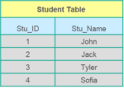APrimary keyis a column (or collection of columns) or a set of columns that uniquely identifies each row in the table.
* Uniquely identifies a single row in the table
* Null values not allowed

Example- In the Student table, Stu_ID is the primary key.

**What are Constraints?**

Constraints are used to specify the limit on the data type of the table. It can be specified while creating or altering the table statement. The sample of constraints are:

* NOT NULL
* CHECK
* DEFAULT
* UNIQUE
* PRIMARY KEY
* FOREIGN KEY

**What is the difference between DELETE and TRUNCATE statements?**

|  |  |
| --- | --- |
| **DELETE vs TRUNCATE** | |
| **DELETE** | **TRUNCATE** |
| Delete command is used to delete a row in a table. | Truncate is used to delete all the rows from a table. |
| You can rollback data after using delete statement. | You cannot rollback data. |
| It is a DML command. | It is a DDL command. |
| It is slower than truncate statement. | It is faster. |

**What is a Unique key?**

* Uniquely identifies a single row in the table.
* Multiple values allowed per table.

Apart from this SQL Interview Questions blog, if you want to get trained from professionals on this technology, you can opt for a structured training from edureka! Click below to know more.Null values allowed.

**What is a Foreign key?**

* Foreign key maintains referential integrity by enforcing a link between the data in two tables.
* The foreign key in the child table references the primary key in the parent table.
* The foreign key constraint prevents actions that would destroy links between the child and parent tables.

## ****What do you mean by data integrity?****

* Data Integrity defines the accuracy as well as the consistency of the data stored in a database. It also defines integrity constraints to enforce business rules on the data when it is entered into an application or a database.

**What is the difference between clustered and non clustered index in SQL?**

The differences between the clustered and non clustered index in SQL are :

1. Clustered index is used for easy retrieval of data from the database and its faster whereas reading from non clustered index is relatively slower.
2. Clustered index alters the way records are stored in a database as it sorts out rows by the column which is set to be clustered index whereas in a non clustered index, it does not alter the way it was stored but it creates a separate object within a table which points back to the original table rows after searching.
3. One table can only have one clustered index whereas it can have many non clustered index

## ****Write a SQL query to display the current date?****

In SQL, there is a built-in function called GetDate() which helps to return the current timestamp/date.

**List the different type of joins?**

There are various types of joins which are used to retrieve data between the tables. There are four types of joins, namely:

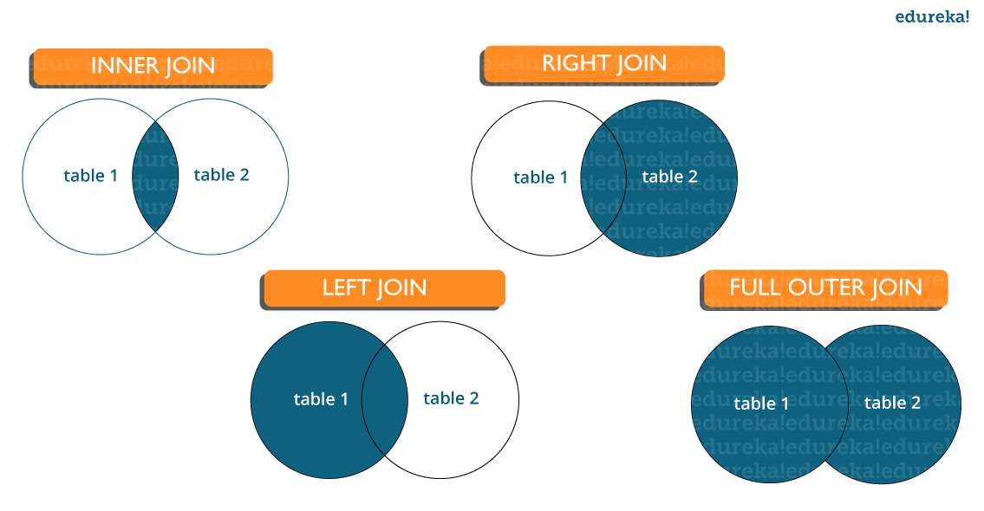

**Inner join:** Inner Join in MySQL is the most common type of join. It is used to return all the rows from multiple tables where the join condition is satisfied.

**Left Join:**  Left Join in MySQL is used to return all the rows from the left table but only the matching rows from the right table where the join condition is fulfilled.

**Right Join:** Right Join in MySQL is used to return all the rows from the right table but only the matching rows from the left table where the join condition is fulfilled.

**Full Join:** Full join returns all the records when there is a match in any of the tables. Therefore, it returns all the rows from the left-hand side table and all the rows from the right-hand side table.

**What do you mean by Denormalization?**

Denormalization refers to a technique which is used to access data from higher to lower forms of a database. It helps the database managers to increase the performance of the entire infrastructure as it introduces redundancy into a table. It adds the redundant data into a table by incorporating database queries that combine data from various tables into a single table.

**What are Entities and Relationships?**

**Entities**:  A person, place, or thing in the real world about which data can be stored in a database. Tables store data that represents one type of entity. For example – A bank database has a customer table to store customer information. Customer table stores this information as a set of attributes (columns within the table) for each customer.

**Relationships**: Relation or links between entities that have something to do with each other. For example – The customer name is related to the customer account number and contact information, which might be in the same table. There can also be relationships between separate tables (for example, customer to accounts).

**What is an Index?**

An index refers to a performance tuning method of allowing faster retrieval of records from the table. An index creates an entry for each value and hence it will be faster to retrieve data.

**Explain different types of index.**

There are three types of index namely:

**Unique Index:**

This index does not allow the field to have duplicate values if the column is unique indexed. If a primary key is defined, a unique index can be applied automatically.

**Clustered Index:**

This index reorders the physical order of the table and searches based on the basis of key values. Each table can only have one clustered index.

**Non-Clustered Index:**

Non-Clustered Index does not alter the physical order of the table and maintains a logical order of the data. Each table can have many nonclustered indexes.

**What is Normalization and what are the advantages of it?**

Normalization is the process of organizing data to avoid duplication and redundancy. Some of the advantages are:

* Better Database organization
* More Tables with smaller rows
* Efficient data access
* Greater Flexibility for Queries
* Quickly find the information
* Easier to implement Security
* Allows easy modification
* Reduction of redundant and duplicate data
* More Compact Database
* Ensure Consistent data after modification

Apart from this SQL Interview Questions Blog, if you want to get trained from professionals on this technology, you can opt for a structured training from edureka! Click below to know more.

**What is the difference between DROP and TRUNCATE commands?**

DROP command removes a table and it cannot be rolled back from the database whereas TRUNCATE command removes all the rows from the table.

**Explain different types of Normalization.**

There are many successive levels of normalization. These are called **normal forms**. Each consecutive normal form depends on the previous one.The first three normal forms are usually adequate.

* *First Normal Form (1NF)* – No repeating groups within rows
* *Second Normal Form (2NF)* – Every non-key (supporting) column value is dependent on the whole primary key.
* *Third Normal Form (3NF)* – Dependent solely on the primary key and no other non-key (supporting) column value.

**Can you tell something about the Primary key in SQL and what is its significance?**

**Ans:**It is basically an array or a group of fields that generally specify a row. It is considered as one of the unique keys that always have some defined or specific value. Generally, the users need not worry about anything when it is enabled as it cannot have a null value.

It is capable to identify all the records in a database simply and the users are free to get the best possible outcome with minimum efforts. This is exactly what that makes sure of uniqueness.

**What do you know about database testing and how it can help to get useful results for the database users?**

**Ans:**It is basically nothing but the back end testing or data testing. It generally involves keeping an eye on the integrity of the data an organization use. It generally validates some of the very useful tasks such as database, indexes, columns, tables as well as triggers. IT also make sure that no duplicate data exist in the database which causes a very large number of problems and the best part is the junk records can also be trashed in a very reliable manner. The updating of the record is also a task that can be made easy with the help of this approach.

**In SQL, what do you know about the composite primary key?**

**Ans:**The key which is created on multiple columns in a table is generally considered as the Composite primary key. However, it is not always necessary that all of them have the same meaning.

**In a query, is it possible for the users to avoid the duplicate records? How this can be done?**

**Ans:**Yes, the same is possible and there are many methods that can help users to get the favorable fortune in this matter. The best one is to deploy the **SQL SELECT DISTINCT** query which issued to return the unique values. All the repeated values or the ones which are duplicate get deleted automatically.

**What do you know about the NULL value in the SQL?**

**Ans:**It is basically a field which doesn’t have any value in SQL. It is totally different from that of a zero value and must not be put equal or confused with the same. These fields are left blank during the creation of the records.